"The monsoon season brings much needed rain for agriculture this year"
successfully returned a NOT A DISASTER flag with 58.62% confidence.

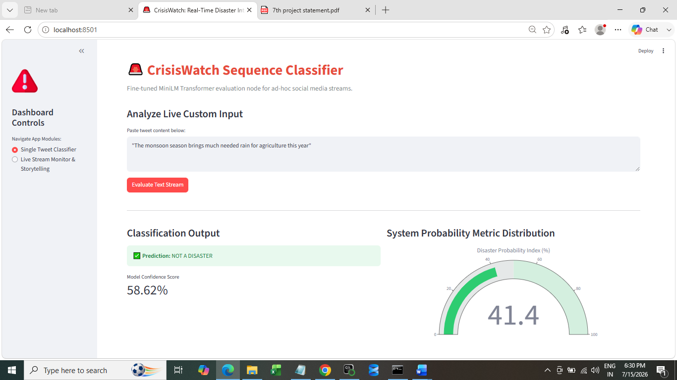

"Urgent rescue teams deployed to northern sector due to monsoon landslides"
cleanly triggered a DISASTER EVENT DETECTED flag with 96.97% system confidence.

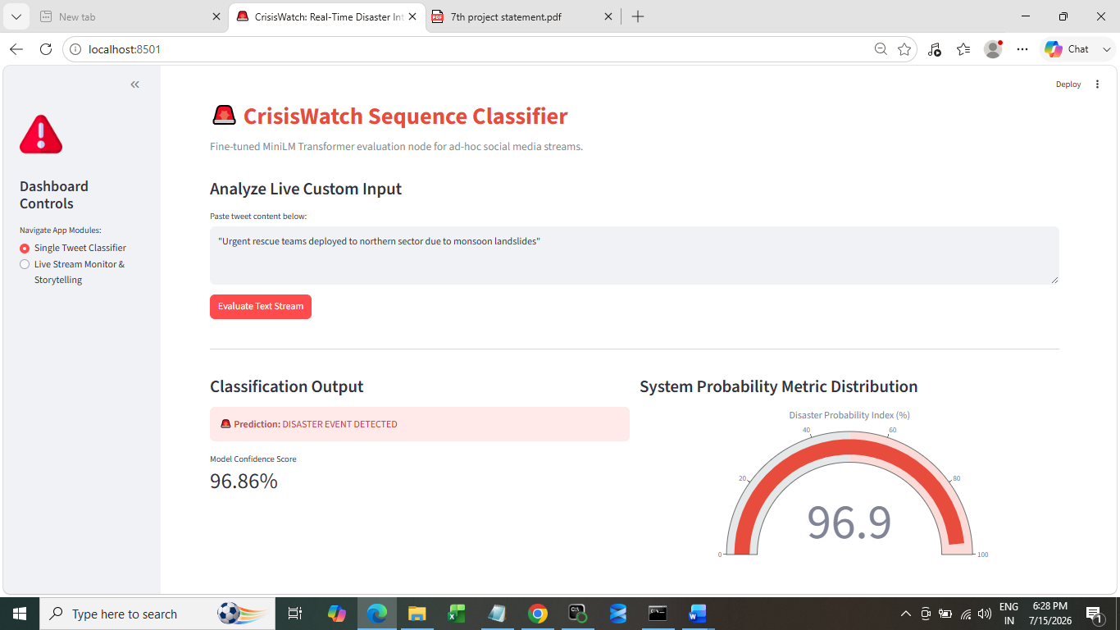

My uncle is cutting tree
Model Confidence Score - 82.90%

